**UI User Guide**

1. Run the program ‘main.m’ and a simple UI will pop up
2. A sample image is provided with the example. Choose ‘sample_image.dv’ from where you downloaded it. It is an image of fission yeast with fluorescently labeled nuclear membrane and lac operators. Select ‘FluorescentParticle3D’ as the type of channel 1 and select ‘FluorescentMembrane3D’ as the type of channel 2. Labels of channels are optional. Click next to go to the next view. 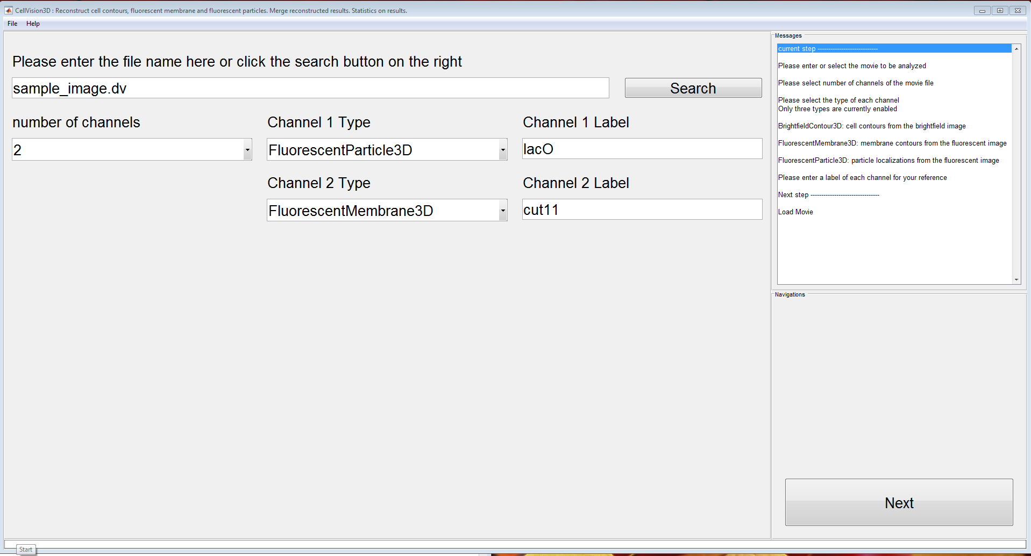
3. The program will do an initial analyze of each channels and show you the results. 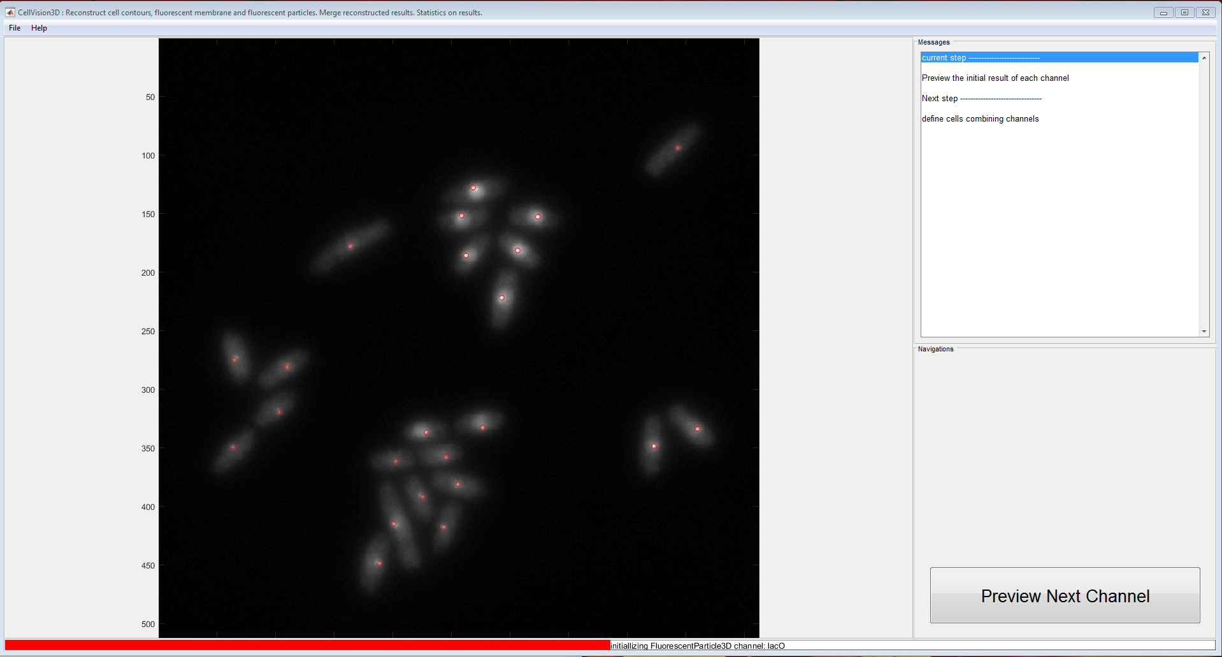
4. This view decides the relation between different channels. Select ‘fluorescent membrane and fluorescent particles inside the membrane’, it will figure out which particles belongs to nuclei. Currently only a basic cell filter is implemented. More filters can be added programmably. Choose FilterType to be ‘FluorescentParticle_number’, and set the min value and max value to 1. This will filter out cells which has multiple particles or has no particles. 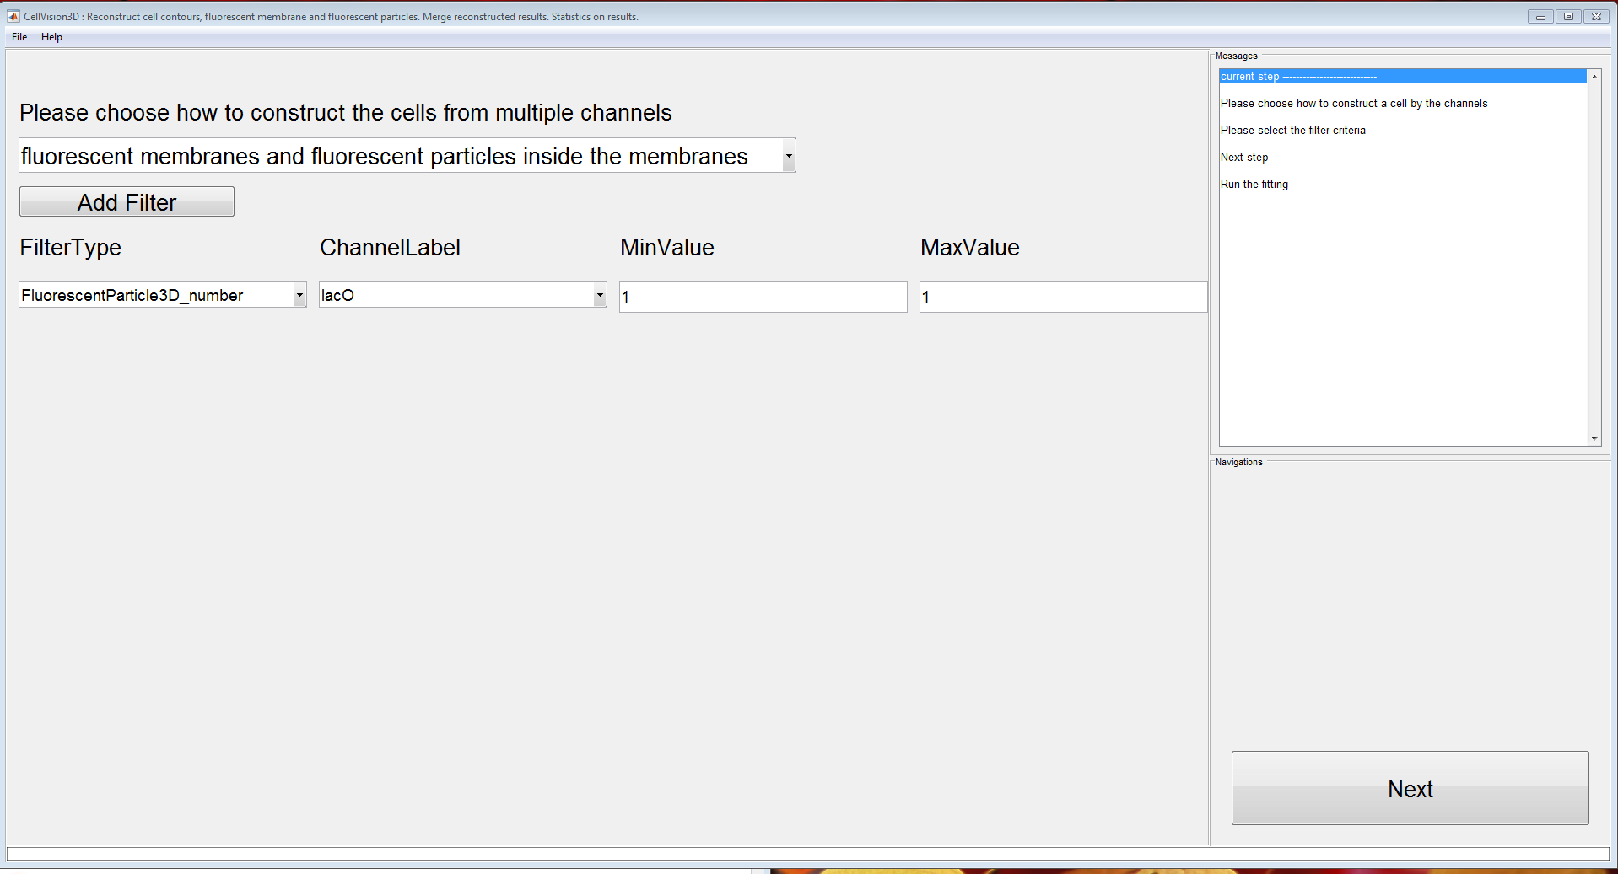
5. The program will analyze each channel. Intermediary results will be shown. 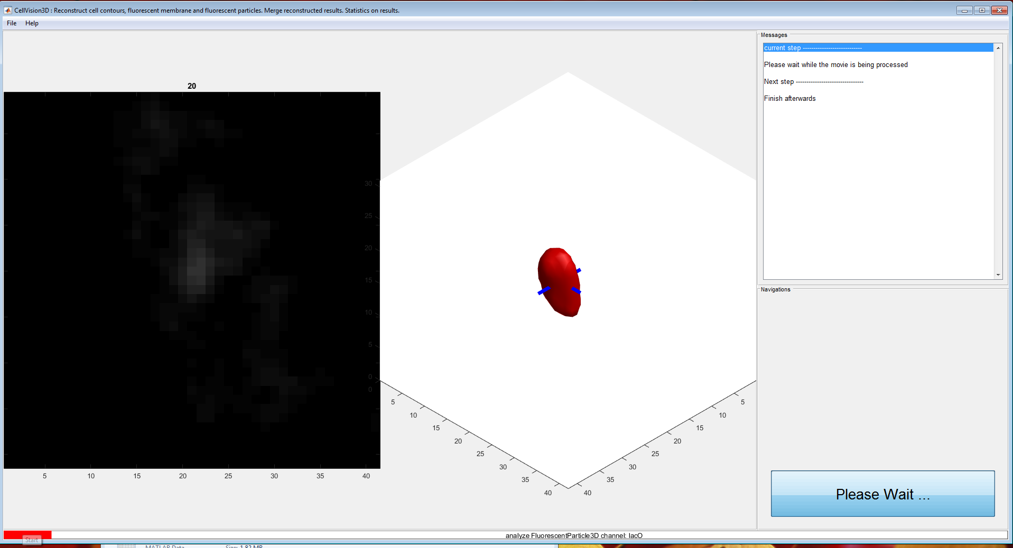

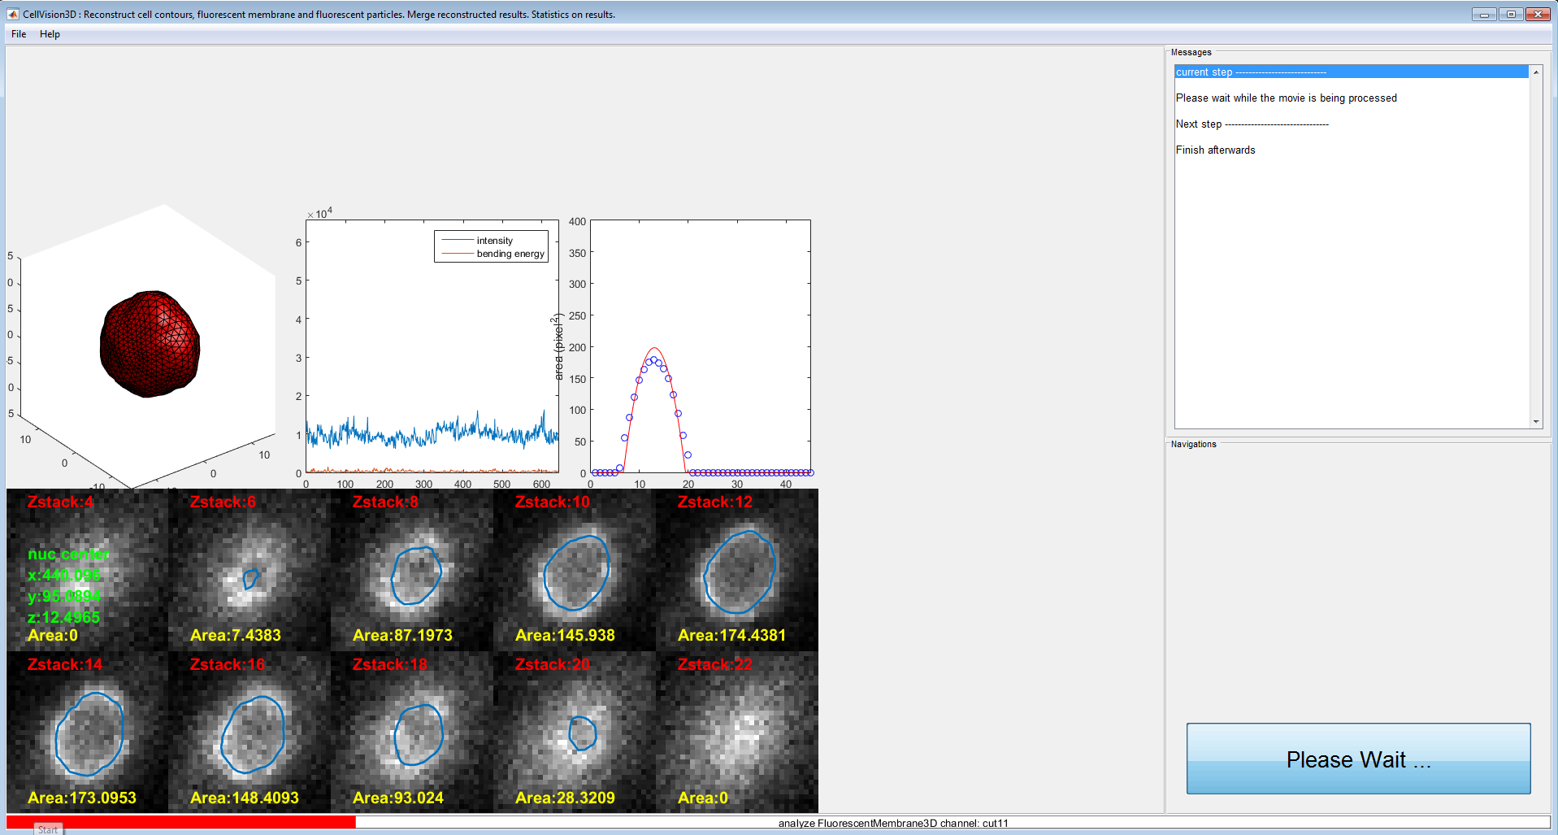

1. Click ‘Save and Close’ button. The program saves the tracks and shapes of the analyzed cells to a designated file. To analyze the result, please check the data structure of particles and contours to use the data . 